MINUTES
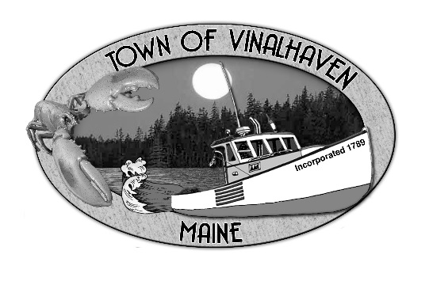
Town of Vinalhaven
Board of Selectmen

Tuesday, May 25, 2021
5:30 pm

- Roll Call - Selectmen Eric Gasperini, Phil Crossman, Pam Alley, Donald Poole and Jacob Thompson; Town Manager Andrew Dorr; and Deputy Town Clerk Elizabeth Bunker.
Attending virtually – Gabe McPhail, Matt Jablonski, Janann Sherman, Millie Martin, Julie Peterson, and Austin James.
- Approve Agenda –Motion by Eric Gasperini to approve the agenda as presented. Second by Pam Alley. Vote 5-0-0. Motion carried.
- Minutes – Approve the minutes from the May 11, 2021 meeting. Motion by Eric Gasperini to approve the minutes from the May 11, 2021 meeting. Second by Donald Poole. Vote 5-0-0. Motion carried.
- Approve and Sign Treasurer’s Warrant #47 – Motion by Eric Gasperini to approve and sign Treasurer’s Warrant #47. Second by Donald Poole. Vote 5-0-0. Motion carried.
- Communications - None
- Speakers from the Floor – Millie spoke on behalf of the 4th of July committee. They are asking how the Town feels about holding a traditional 4th of July celebration. Eric said that with mandates being less restricting that he was ok with advertising as a traditional celebration. Masks and hand sanitizer will still be offered. The committee also asked about event insurance. The Town’s carrier would require each vendor to have individual insurance as well. Eric didn’t feel the Town needed to obtain event insurance for this instance.
- Committee and Department Reports/Appointments
  - Planning and Community Development
    - Climate Adaptation Equity Handbook– Gabe asked if there were any questions or concerns about the draft handbook that was sent to board members. Everyone was comfortable with the language presented.
    - Downtown Project Outreach – Not completed yet due to grant funding status unknowns. Gabe is hopeful there will be something to present by next meeting.
  - Fox Islands Broadband Task Force – Gabe asked for some clarification on wording before sending out a mailing. It was agreed that it is a Public Hearing, and no action will be taken at the meeting. The intent is for questions, comments, and concerns to be discussed with the committee and Select Board. Gabe will send a draft to the committee. Informational material will be available with survey results and the proposed project. Andy was asked to see if the auditorium would be available for the June 10 hearing.
  - Road Commissioner Report – The Board reviewed Dan Bickford’s report. The crew is finishing gravel road work (grading and calcium-chloride), Luke Philbrook is continuing to do culvert work on Round the Island Road. Some things have been moved into the new Public Works garage; work is scheduled to be complete by the first week of June. The Swap Shop will have use of the old Public Works space. Carrying Place Bridge received the base layer of tar yesterday (5/24) and guardrails will be installed next week.
- Old Business
  - Approve and Sign Annual Town Meeting Warrant for June 23, 2021 – Motion by Eric Gasperini to approve and sign the Annual Town Meeting warrant. Second by Pam Alley. Vote 5-0-0. Motion carried. Passed for signatures.
- New Business
  - Authorization for Federal Funding – In order to receive some of the funding from the grants that have been applied for the Board will need to authorize Andy to sign and act on their behalf. Motion by Phil Crossman to give Andrew Dorr authority to act on behalf of the Selectmen to expedite the receipt of federal grant funding. Second by Pam Alley. Vote 5-0-0. Motion carried.
An extension has been requested to answer all clarifying questions from the funder.
  - Carrying Place Bridge Bond RFP Opening and Approval – The Board reviewed four returns from Machias Savings, Camden National Bank, The First, and Androscoggin. They also reviewed current commitments, project already committed to, and known upcoming projects. Motion by Donald Poole to accept the rates from Machias Savings for a 10-year bond at 2.49%. Second by Eric Gasperini. Vote 5-0-0. Motion carried.
  - Covid Building Use Policy – Andy is still waiting to see what OSHA and the Bureau of Labor recommend after reviewing the latest CDC announcements. The Library and Town Office will still be asking customers to wear a mask while inside the building. There was a consensus of the Board to wait to see if OSHA/BOL have any recommendations forthcoming and limit use of the building to Town committees for now, to be revisited next meeting.
- Report from Town Manager – The Board reviewed Andy’s memo. Carrying Place Bridge is nearing completion. The new bridge is 2’ higher than the old one so the crew is working on the approaches and will also fix the boat launch when the temporary road is removed. Andy has asked about purchasing left over materials (“waste blocks,” etc.) when the project is complete, and funds could come from the road repair budget.
- Report of Members – Eric said that now the mask mandate has been lifted, he strongly encourages anyone wishing to address the Select board to attend in person. Gabe also commented that the hybrid format was a good option for encouraging engagement and participation.
There was discussion on scheduling a time to meet with the North Haven Selectmen. They meet every Wednesday at 5. There was a consensus of the Board to schedule June’s regular Selectmen Meetings to June 15 and 29, and ask North Haven if they would like to meet either Monday, June 7, or Wednesday June 16, at their regular meeting.
- Adjourn – Motion to adjourn by Phil Crossman at 6:51pm. Second by Jake Thompson. Vote 5-0-0. Motion carried.

Respectfully Submitted,
_________________________________
Elizabeth Bunker, Deputy Town Clerk

Upcoming:
Voting – June 8, 2021
Board of Selectmen Meeting – June 15, 2021
Annual Town Meeting – June 23, 2021
Board of Selectmen Meeting – June 29, 2021

