MINUTES
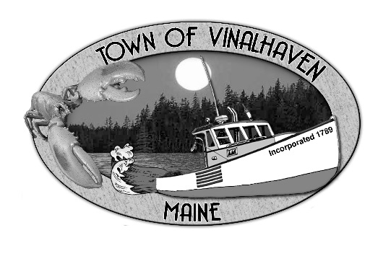
Town of Vinalhaven
Board of Selectmen

Wednesday, June 16, 2021
5:15 pm
Joint Meeting with North Haven Selectmen (virtually)
- Roll Call - Vinalhaven Selectmen Eric Gasperini, Phil Crossman, Pam Alley, Jacob Thompson, Donald Poole; Vinalhaven Town Manager Andrew Dorr; and Deputy Town Clerk Elizabeth Bunker
North Haven Selectmen Jon Demmons, Linda Darling, Jeremiah MacDonald, Patsy Lannon, and Alex Curtis; and North Haven Town Manager Rick Lattimer
Also present: Deputy Josh Lamoie, Deputy Chad Abbott, Jon Emerson, and David Almy
- Approve Agenda -
- New Business
  - Thoroughfare Use/Infrastructure - There was discussion on the following topics.
    - Obtaining a long-term lease with George Lewis. A longer lease would allow the town to apply for grants to help with needed repairs.
    - Improvements needed to the VH side of the Thoroughfare including improve the boat launch, make the ramp ADA assessable, have a longer float, and parking.
    - Approaching the Town of North Haven about a boat launch on their side.
    - The possibility of vehicle transportation someday (FD or EMS mutual aid)
    - Having a ramp that could be accessed by the ferry for inclement weather trips or emergencies.
  - Future Topics - It was agreed that the two Boards would meet quarterly to discuss general concern and try to meet in-person in September.
- Adjourn - Motion by Eric Gasperini to adjourn at 5:56pm. Second by Donald Poole. Vote 5-0-0. Motion carried.
Respectfully Submitted,
_________________________________
Elizabeth Bunker, Deputy Town Clerk

Upcoming:
June 23, 2021 - Annual Town Meeting @ SHMH
June 29, 2021 - Regular Selectmen’s Meeting

