MINUTES- Special Site Visit
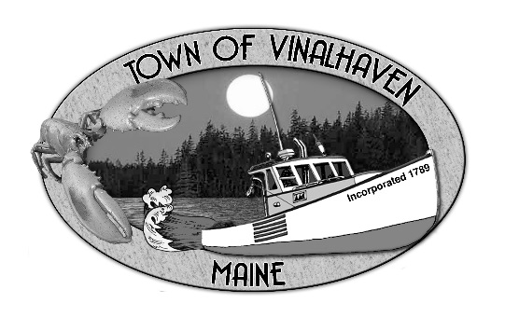
Town of Vinalhaven
Board of Selectmen

Thursday, August 15th, 2019
4:00 PM
Mill’s Property - Loud’s Pit Road

- Roll Call
Eric Gasperini, Chair, Jake Thompson, Pam Alley, Joy Mills, Andy Dorr

- New Business
  - Site Visit – Mill’s Property - Loud’s Pit Road regarding new Public Works Facility
Andy pointed out that although the BOS authorized an extension, the BOS never motioned to sign the extension at the previous meeting. Andy suggested they do so today and provide that copy to the lawyer.
Eric motioned to sign the contract extension that was agreed upon at the last meeting.
Pam Seconded the motion.
Vote 3/0/0

Discussion about the location of the proposed buried utilities and it was pointed out that it would run between the closest pole and the pin near the culvert closest the proposed building location, reference to the survey provided.

Andy pointed out where the fill from the transfer station/shooting range could go. There is no estimate as to the yards needed to level or create the storage area, but it was clear that the site could accommodate any and all of that material.

General discussion about the location of property lines and pins was had. Andy pointed out where some of the pins were to orient those attending.

- Adjourn
Eric motioned to adjourn at 4:32 pm.
Jake seconded the motion.
Vote 3/0/0

Respectfully Submitted,

________________________________
Andrew J. Dorr, Town Manager

