AGENDA
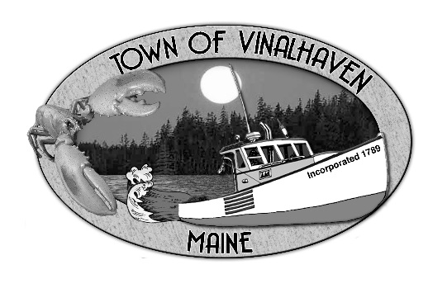

Town of Vinalhaven
Board of Selectmen

Monday, April 22th, 2019
IMMEDIATELY FOLLOWING PUBLIC HEARING
TOWN OFFICE

- Roll Call

- Minutes – Approve the minutes from the April 8th, 2019 Meeting and April 15th, 2019 Budget Meeting

- Approve and Sign Treasurer’s Warrants # 43

- Approve Agenda
- Communications

- Speakers from the Floor

- Committee and Department Reports/Appointments
  - Appointment to the Sewer Commission
  - Ambulance Report
  - Road Commissioner
  - Sea Level Rise Committee

- Old Business
  - Town Report Dedication & Memoriam
  - 2017 Tax Foreclosures
  - MSFS - Rate Proposal

- New Business
  - Special Town Meeting Warrant - Harbor Ordinance
  - Annual Town Meeting Warrant

- Report of Town Manager

- Report of Members

- Adjourn

