AGENDA
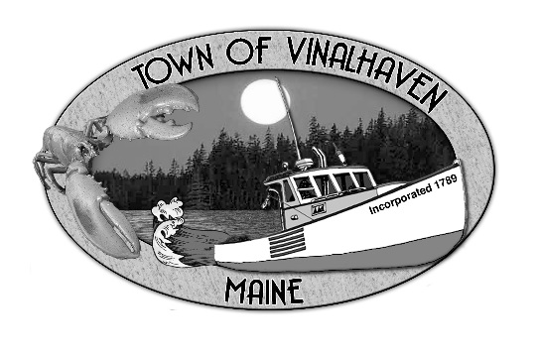

Town of Vinalhaven
Board of Selectmen

MONDAY, April 8th, 2019
6:00 PM
TOWN OFFICE

- Roll Call

- Minutes – Approve the minutes from the March 25th, 2019 Meeting

- Approve and Sign Treasurer’s Warrants # 41

- Approve Agenda
- Communications

- Speakers from the Floor

- Committee and Department Reports/Appointments
  - Appointment to the Park Commission
  - Ambulance Report
  - Cemetery Committee
  - Knox County Sheriff’s Office
  - Road Commissioner
  - Transfer Station
  - Treasurer’s Report

- Old Business
  - Town Report Dedication & Memoriam
  - 2017 Tax Foreclosures

- New Business
  - MSFS
    - Rate Proposal
    - USCG Letter - Emergency Trips
    - MeDOT Commissioner Meeting
  - Cemetery Mowing Contract Review
  - Set date for Public Hearing for Harbor Ordinance

- Report of Town Manager

- Report of Members

- Adjourn

