AGENDA
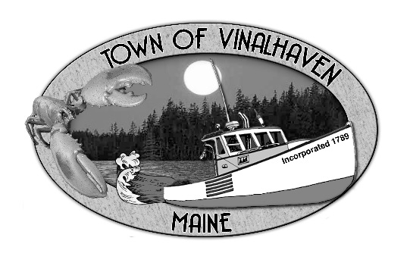
Town of Vinalhaven
Board of Selectmen

TUESDAY, August 13th, 2019
6:00 PM or
TOWN OFFICE

- Roll Call

- Minutes – Approve the minutes from the July 8th, 2019 Meeting; the July 22nd, 2019 Meeting; and the July 30th, 2019 Meeting

- Approve and Sign Treasurer’s Warrants # 7

- Approve Agenda
- Communications

- Speakers from the Floor

- Committee and Department Reports/Appointments
  - Accept and Appropriate Donations
  - Appointment to the Sewer Commission
  - Road Commissioner’s Report
  - Woodard & Curran Status Report

- Old Business
  - Public Works Garage Update
  - Public Works Equipment – Asphalt Hot Box
  - Star of Hope Building Improvements Update

- New Business
  - FY 20 Fuel Oil Bids
  - Surplus Equipment Bids – Jeep
  - Town Property - Public Meetings Policy
  - Equipment Reserve - Computer Purchase
  - Sewer FY 20 Budget Approval
  - Selectmen’s Goals 2019-2020

- Report of Town Manager

- Report of Members

- Executive Session - Executive Session pursuit to 1 M.R.S.A. § 405(6)(C) - Acquisition of Real Property

- Adjourn

