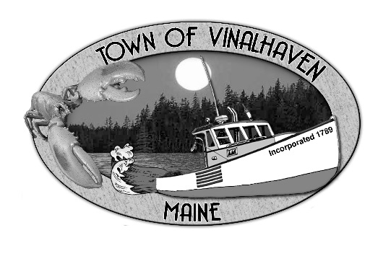
Town of Vinalhaven
Board of Selectmen

AGENDA
Tuesday, February 11th, 2020
5:30 PM
Vinalhaven Town Office

- Roll Call

- Minutes – Approve the minutes from the January 28th, 2020 Meeting

- Approve and Sign Treasurer’s Warrants # 33

- Approve Agenda
- Communications

- Speakers from the Floor

- Committee and Department Reports/Appointments
  - Accept and Appropriate Donations
  - Appointments to the Planning Commission
  - Ambulance Reports
  - Planning and Community Development
  - Downtown Master Plan
  - Knox County Sheriff’s Office Report
  - Sea Level Rise Committee Update
  - Broadband (FIBTF)
  - Road Commissioner’s Report
  - Transfer Station
  - Woodard & Curran Status Report

- Old Business
  - Capital Projects Update

- New Business
  - Approve Special Town Meeting Warrant
  - Approve US Census BVP
  - Vinalhaven Tick Committee
  - Budget Review

- Report of Town Manager

- Report of Members

- Executive Session - pursuant to 1 M.R.S.A. § 405(6)(A) – Personnel Matter

- Adjourn

