AGENDA
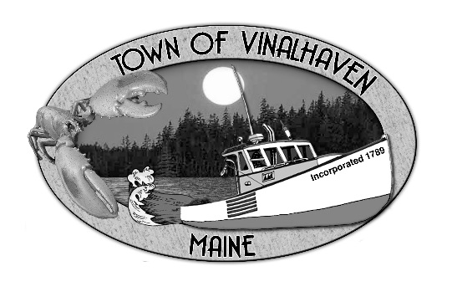

Town of Vinalhaven
Board of Selectmen

Tuesday, February 12th, 2019
TOWN OFFICE

- Roll Call

- Executive Session pursuant to 1 M.R.S.A. § 405(6)(A) to discuss a Personnel Matter

- Minutes – Approve the minutes from the January 22nd, 2019 Meeting

- Approve and Sign Treasurer’s Warrants # 33

- Approve Agenda
- Communications
  - MeDOT

- Speakers from the Floor

- Committee and Department Reports/Appointments
  - Approve & Appropriate Donations
  - Ambulance Reports
  - Road Commissioner
  - Knox County Sheriff’s Report

- Old Business
  - Lane’s Island Bridge – Guardrails and Grout

- New Business
  - Sewer Infrastructure Grant
  - Surplus Equipment

- Report of Town Manager

- Report of Members

- Adjourn

