AGENDA
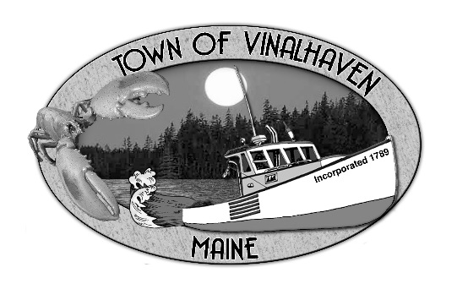

Town of Vinalhaven
Board of Selectmen

Tuesday, February 26th, 2019
6:00 PM
TOWN OFFICE

- Roll Call

- Minutes – Approve the minutes from the February 12th, 2019 Meeting and the February 19th, 2019 Budget Workshop

- Approve and Sign Treasurer’s Warrants # 35

- Approve Agenda
- Communications

- Speakers from the Floor

- Committee and Department Reports/Appointments
  - Road Commissioner

- Old Business
  - Proposed Building Permit Fees

- New Business
  - Budget Workshop
    - Washington School
    - Town Properties
    - Law Enforcement
    - Harbor Master
    - ACO

- Report of Town Manager

- Report of Members

- Adjourn

