AGENDA
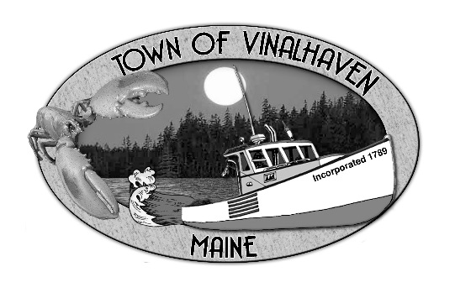

Town of Vinalhaven
Board of Selectmen

Wednesday, February 27th, 2019
6:00 PM
TOWN OFFICE

- Roll Call

- Approve Agenda
- Speakers from the Floor

- New Business
  - Budget Workshop
    - Fire Dept.
    - Ambulance
    - Public Safety Building
    - CEO/LPI
    - Cemetery
    - Planning
    - Library

- Report of Town Manager

- Report of Members

- Adjourn

