AGENDA
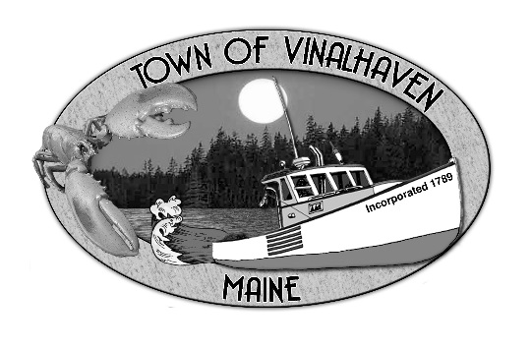

Town of Vinalhaven
Board of Selectmen

Tuesday, January 22nd, 2019
Immediately Following Public Hearing (6:00 PM)
TOWN OFFICE

- Roll CALL

- Minutes – Approve the minutes from the January 8th, 2019 Meeting and the January 14th, 2019 Meeting
- Approve And Sign Treasurer’s Warrants # 30

- Approve Agenda
- Communications

- Speakers from the Floor

- Committee and Department Reports/Appointments
  - Road Commissioner

- old business
  - Lane’s Island Bridge – Guardrails and Grout
  - Potential Paving Projects
  - Proposed Building Permit Fees

- New Business
  - Liquor License Application – Kristine Davidson d/b/a SKÅL

- Report of Town Manager

- Report of Members

- Adjourn

