AGENDA
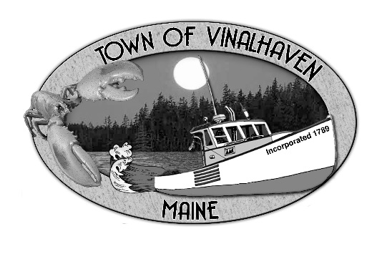

Town of Vinalhaven
Board of Selectmen

Tuesday, January 8th, 2019
6:00 PM
TOWN OFFICE

- Roll CALL

- Minutes – Approve the minutes from the December 27th, 2018 Meeting
- Approve And Sign Treasurer’s Warrants # 28

- Approve Agenda
- Communications
  - Community Read Program Request

- Speakers from the Floor

- Committee and Department Reports/Appointments
  - Cemetery Committee
  - MSFS Advisory Board Members
  - Road Commissioner

- old business
  - Harbor Ordinance
  - Law Enforcement on Vinalhaven
  - Public Works Garage

- New Business
  - Lane’s Island Bridge – Guardrails and Grout
  - Potential Paving Projects
  - Proposed Building Permit Fees
  - Engineering Services
  - FY 20 Budget Update: Department Goals

- Report of Town Manager

- Report of Members

- Adjourn

