AGENDA
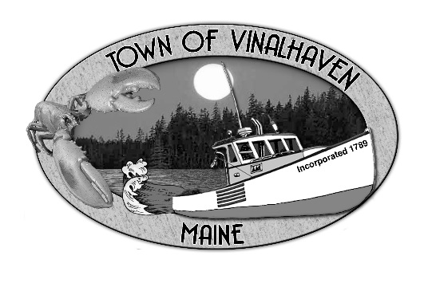
Town of Vinalhaven
Board of Selectmen

Monday, July 22th, 2019
6:00 PM or
Immediately Following Executive Session to begin at 5:30 PM
TOWN OFFICE

- Roll Call

- Executive Session – Pursuant to MRSA 1 Section 405(6)(c).

- Minutes – Approve the minutes from the July 8th, 2019 Meeting

- Approve and Sign Treasurer’s Warrants # 4

- Approve Agenda
- Communications

- Speakers from the Floor

- Committee and Department Reports/Appointments
  - Planning Board Appointment
  - Sewer Commissioner’s Appointment
  - Road Commissioner
  - Transfer Station Report
  - Woodard & Curran Status Report

- Old Business
  - Public Works Garage
    - Update on P&S
    - Cost Estimates
  - Star of Hope Building Improvements Update

- New Business
  - Broadband RFP – Final Review
  - Town Parks/Property - Rules/Policy/Ordinance
  - Fire Department Training Grant
  - Surplus Equipment – Jeep
  - Public Works Equipment – Post Driver and Asphalt Hot Box
  - Vinalhaven Ferry Tariff Committee Mission
  - Sewer Abatement
  - Sewer FY 20 Budget Approval
  - Selectmen’s Goals 2019-2020

- Report of Town Manager

- Report of Members

- Adjourn

