AGENDA
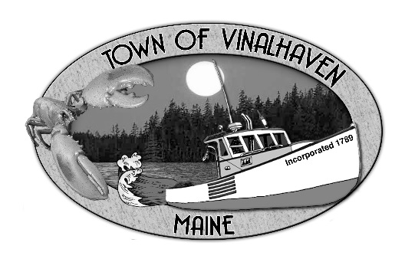
Town of Vinalhaven
Board of Selectmen

Monday, July 8th, 2019
6:00 PM
TOWN OFFICE

- Roll Call

- Minutes – Approve the minutes from the June 24th, 2019 Meeting

- Approve and Sign Treasurer’s Warrants # 2

- Approve Agenda
- Communications
  - Hurricane Island

- Speakers from the Floor

- Committee and Department Reports/Appointments
  - Annual Municipal Official, Board & Committee Appointments
  - Accept & Appropriate Donations
  - Waste Watchers
  - Road Commissioner
  - Woodard & Curran Status Report

- Old Business
  - Dangerous Building – Star of Hope
  - Harbor Ordinance - Parking Permits
  - Housing
  - Public Works Garage Design - Draft
  - Galamander Work

- New Business
  - Municipal Quitclaim Deed

- Report of Town Manager

- Report of Members

- Adjourn

