AGENDA
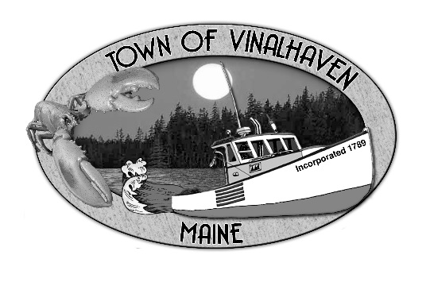

Town of Vinalhaven
Board of Selectmen

Monday, June 10th, 2019
6:00 PM
TOWN OFFICE

- Roll Call

- Minutes – Approve the minutes from the May 20th, 2019 and May 29th, 2019 Meetings

- Approve and Sign Treasurer’s Warrants # 50

- Approve Agenda
- Communications
  - MSFS Advisory Board

- Speakers from the Floor

- Committee and Department Reports/Appointments
  - Ambulance Reports
  - Downtown Committee Report
  - Library Trustees Appointment
  - Road Commissioner Reports
  - Transfer Station Analysis Report
  - Woodard & Curran Status Report

- Old Business
  - Ames Cove Road
  - 2019 Road Paving Update
  - Surplus Equipment
  - PW Garage Update

- New Business
- Dangerous Building
- York Road – Personal Property Damage
- Flea Market
- Parking Lot Requests
- Annual Contract(s) - Draft
  - Cemetery
  - Knox County Sheriff
- Annual Lease Agreements – Draft
  - Indian Creek
  - Thorofare
  - Engine House Press
  - Rockland Animal Hospital

- Report of Town Manager

- Report of Members

- Adjourn

