AGENDA
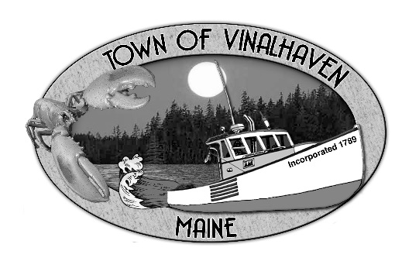
Town of Vinalhaven
Board of Selectmen

Monday, June 24th, 2019
6:00 PM
TOWN OFFICE

- Roll Call
  - Appoint Chair & Co-Chair

- Executive Session - Executive Session pursuant to 1 M.R.S.A. § 405(6)(E) for consultation with legal counsel

- Minutes – Approve the minutes from the June 10th, 2019 Meeting

- Approve and Sign Treasurer’s Warrants # 52

- Approve Agenda
- Communications

- Speakers from the Floor

- Committee and Department Reports/Appointments
  - Annual Municipal Official, Board & Committee Appointments
  - Accept & Appropriate Donations
  - Downtown Committee
  - Sea-Level Rise
  - Waste Watchers
  - Ambulance Reports
  - Road Commissioner
  - Woodard & Curran Status Report

- Old Business
  - Dangerous Building – Star of Hope
  - Community Bulletin Board

- New Business
  - Deer and Ticks
  - Sign Request
  - Harbor Ordinance - Parking Permits
  - Housing
  - Sign Annual Contracts
    - Cemetery
    - Knox County Sheriff
  - Sign Annual Lease Agreements
    - Indian Creek
    - Engine House Press
    - Thorofare
    - Rockland Animal Hospital
  - Public Works Garage Design - Draft

- Report of Town Manager

- Report of Members

- Adjourn

