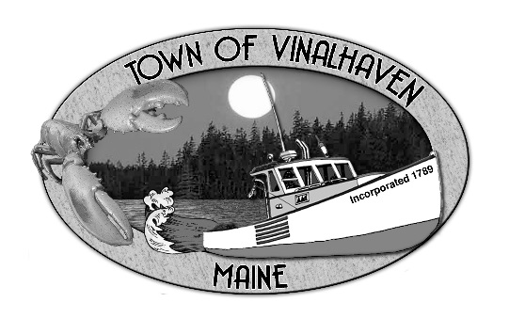
Town of Vinalhaven
Board of Selectmen

AGENDA
Wednesday, March 25th, 2020
5:00 PM
Emergency Meeting
Vinalhaven Town Office
*Virtual Participation of the BOS will be in practice.

- Roll Call

- Approve Agenda
- COVID-19 Community Update

- Adjourn

**The general public will not be able to gather in the building, but instead can view the meeting live at our Town’s Facebook page.
www.facebook.com/townofvinalhaven
There will be a delayed recording available within 24 hours on the Town’s YouTube page.
www.youtube.com and search for Town of Vinalhaven

