AGENDA
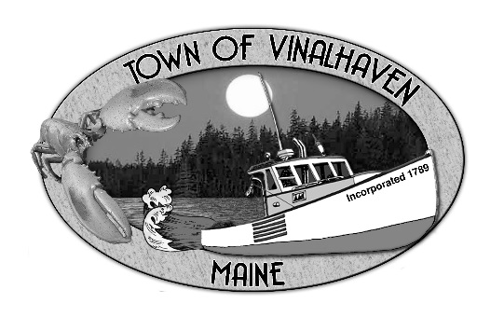

Town of Vinalhaven
Board of Selectmen

MONDAY, March 25th, 2019
5:30 PM
TOWN OFFICE

- Roll Call

- Executive Session - Executive Session pursuant to 1 M.R.S.A. § 405(6)(E) for consultation with legal counsel

- Public Hearing – Liquor License Application for Kelly Weiss & Amy Walsh d/b/a Dot & Millie’s LLC

- Public Presentation – Penobscot Island Air

- Minutes – Approve the minutes from the February 26th, 2019 Meeting and the March 11th, 2019 Meeting

- Approve and Sign Treasurer’s Warrants # 39

- Approve Agenda
- Communications
  - Community Calendar Request

- Speakers from the Floor

- Committee and Department Reports/Appointments
  - Road Commissioner

- Old Business
  - Town Report Dedication & Memoriam
  - 2017 Tax Foreclosures

- New Business
  - Liquor License Application for Kelly Weiss & Amy Walsh d/b/a Dot & Millie’s LLC
  - Engineering Scope/Work Order
    - PW Facility
    - Carrying Place Bridge
    - Transfer Station
  - Cemetery Mowing Contract Review
  - Budget Workshop

- Report of Town Manager

- Report of Members

- Adjourn

