AGENDA
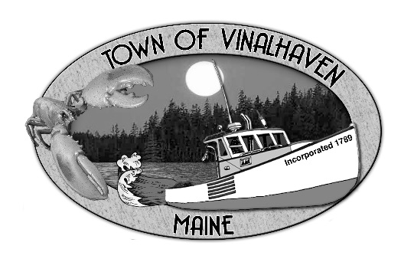

Town of Vinalhaven
Board of Selectmen

Monday, May 13th, 2019
IMMEDIATELY FOLLOWING SPECIAL TOWN MEETING (6:00 PM)
TOWN OFFICE

- Roll Call

- Minutes – Approve the minutes from the April 22th, 2019 Meetings

- Approve and Sign Treasurer’s Warrants # 46

- Approve Agenda
- Communications

- Speakers from the Floor

- Committee and Department Reports/Appointments
  - Ambulance Reports
  - Road Commissioner

- Old Business

- New Business
  - Galamander
  - Draft Cemetery Ordinance
  - Liquor License Application - Lindsay Davis d/b/a The Sand Bar
  - Catered Function Liquor License Application - Broadwing Farm LLC d/b/a Harvest Moon
  - Approve and sign Annual Town Election Warrant - June 11th, 2019
  - Approve and sign MSAD # 8 Election Warrant - June 11th, 2019
  - Webster Beckman Smith - Games of chance

- Report of Town Manager

- Report of Members

- Adjourn

