AGENDA
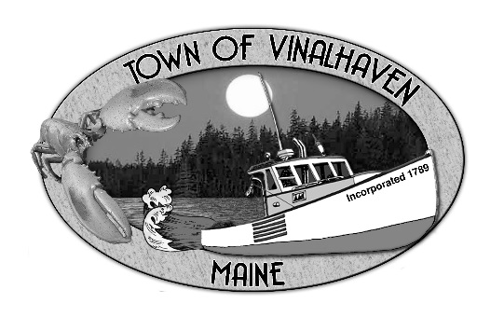

Town of Vinalhaven
Board of Selectmen

Monday, May 20th, 2019
6:00 PM
TOWN OFFICE

- Roll Call

- Executive Session - Executive Session pursuant to 1 M.R.S.A. § 405(6)(E) for consultation with legal counsel

- Minutes – Approve the minutes from the May 13th, 2019 Meetings

- Approve and Sign Treasurer’s Warrants # 47

- Approve Agenda
- Communications

- Speakers from the Floor

- Committee and Department Reports/Appointments
  - Accept & Appropriate Donations
  - Knox County Sheriff’s Office Report
  - Road Commissioner
  - Transfer Station Analysis

- Old Business
  - Star of Hope Update
  - Cemetery Ordinance
  - Ames Cove Road

- New Business
  - Aquaculture Lease - Hayden Jones & Shelby Smith
  - Deputy Harbor Master
  - 2019 Road Paving Update
  - Surplus Equipment

- Report of Town Manager

- Report of Members

- Adjourn

