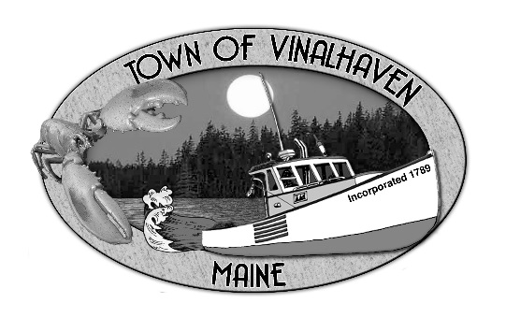
Town of Vinalhaven
Board of Selectmen

AGENDA
Tuesday, November 24th, 2020
5:30 PM
Virtual Meeting*
- Roll Call

- Approve Agenda

- Minutes – Approve the minutes from the November 10th, 2020 Meeting

- Approve and Sign Treasurer’s Warrants #21

- Communications

- Speakers from the Floor

- Committee and Department Reports/ Appointments
  - Appointment to the Budget Committee
  - Road Commissioners Report

- Old Business

- New Business
  - Portrait of a Graduate Presentation
  - Foreclosed Property

- Report from Town Manager

- Report of Members

- Executive Session - Executive Session pursuant to 1 M.R.S.A. §405(6)(E) – Legal Matter

- Adjourn

*If you wish to participate in the discussion, please email or call Andrew Dorr, Town Manager for log-in info.
He can be reached at townmanager@townofvinalhaven.org or 863-2042.

