AGENDA
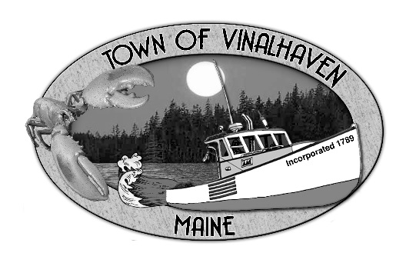
Town of Vinalhaven
Board of Selectmen

Tuesday, November 26th, 2019
Immediately Following Public Hearing (5:30 PM)
Vinalhaven Town Office

- Roll Call

- Minutes – Approve the minutes from the October 29th, 2019 Workshop and the November 12th, 2019

- Approve and Sign Treasurer’s Warrants # 22

- Approve Agenda
- Communications
  - Vinalhaven Yearbook

- Speakers from the Floor

- Committee and Department Reports/Appointments
  - Downtown Revitalization Committee Update
  - Sea Level Rise Committee Update
  - Waste Watchers Update
  - Knox County Sheriff’s Office Reports
  - Road Commissioner’s Report
  - Woodard & Curran Status Report

- Old Business
  - BOS Strategic Plan

- New Business
  - Ambulance Equipment Reserve Purchase Request
  - Draft 2020 Knox County Budget
  - Aquaculture Lease – Phoebe Jekielek

- Report of Town Manager

- Report of Members

- Executive Session - Executive Session pursuant to 1 M.R.S.A. § 405(6)(E) – Legal Matter

- Adjourn

