AGENDA
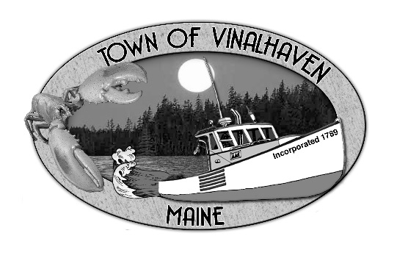
Town of Vinalhaven
Board of Selectmen

Tuesday, October 1st, 2019
Immediately Following Public Haring (6:00 PM)
Vinalhaven Town Office

- Roll Call

- Minutes – Approve the minutes from the September 10th, 2019 Meeting

- Approve and Sign Treasurer’s Warrants # 14

- Approve Agenda
- Communications

- Speakers from the Floor

- Committee and Department Reports/Appointments
  - Downtown Revitalization Committee Update
  - Sea Level Rise Committee Update
  - Waste Watchers Update
  - Road Commissioner’s Report
  - Woodard & Curran Status Report

- Old Business
  - Draft Downtown Master Plan Review

- New Business
  - Review Capital Financing Bids
  - Helicopter Ordinance Review
  - Quarry Ordinance Review
  - Harbor Ordinance
  - General Assistance Ordinance Appendices
  - Quitclaim Deeds - 143 Pequot Road, Pequot Road, and Round the Island Road

- Report of Town Manager

- Report of Members

- Adjourn

