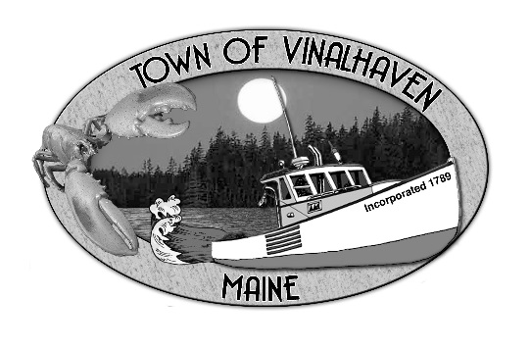
Town of Vinalhaven
Board of Selectmen

AGENDA
Tuesday, October 27th, 2020
Immediately Following Public Hearings (5:30 PM)
Virtual Meeting*
- Roll Call

- Approve Agenda

- Minutes – Approve the minutes from the September 29th, 2020 Meeting

- Approve and Sign Treasurer’s Warrants #15

- Communications
  - Sidewalks

- Speakers from the Floor

- Committee and Department Reports/ Appointments
  - Fox Islands Broadband Task Force Report
  - Planning and Community Development
  - Road Commissioners Report

- Old Business
  - Public Works Garage – Revisit Tenant Agreement

- New Business
  - Possible Action: General Assistance Ordinance and 2020-2021 Maximums
  - Possible Action: Road Closures for Winter Maintenance
  - Possible Action: Purchase of pumps for the Wastewater Department
  - Old Swamp Road Private Access
  - Past Due Sewer Connection Loan Balances

- Report from Town Manager

- Report of Members

- Adjourn

*If you wish to participate in the discussion, please email or call Andrew Dorr, Town Manager for log-in info.
He can be reached at townmanager@townofvinalhaven.org or 863-2042.

