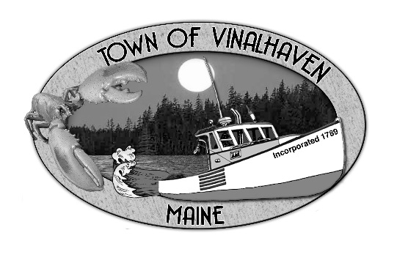
Town of Vinalhaven
Board of Selectmen

AGENDA
Tuesday, September 29th, 2020
5:30 PM
Virtual Meeting*
- Roll Call

- Approve Agenda

- Minutes – Approve the minutes from the September 15th, 2020 Meeting

- Approve and Sign Treasurer’s Warrants #13

- Communications
  - 4th of July Committee – Bandstand Improvements
  - FEMA – LOMR

- Speakers from the Floor

- Committee and Department Reports/ Appointments
  - Harbor Master Summary
  - Road Commissioners Report

- Old Business

- New Business
  - RFP Responses – Open/Review bids
  - Banking Rates – Consider new banking rates
  - EDA Grant Funds – Approve matching funds
  - KSO Contract – Consider signing new contract
  - Social Media and Public Record – Archive Social proposal

- Report from Town Manager

- Report of Members

- Executive Session pursuant to Executive Session - Executive Session pursuant to 1 M.R.S.A. §405(6)(F) –
To discuss an ambulance hardship waiver application.

- Adjourn

*If you wish to participate in the discussion, please email or call Andrew Dorr, Town Manager for log-in info.
He can be reached at townmanager@townofvinalhaven.org or 863-2042.

